AN UNTOUCHABLE CHRISTMAS (Untouchables 2)

By Cindy Skaggs

Press Kit
AN UNTOUCHABLE CHRISTMAS: 2
EXCERPT: 3
SHORT EXCERPT: 3
LINKS: 4
BUY LINKS: 4

AN UNTOUCHABLE CHRISTMAS:
This holiday is one she will never forget.
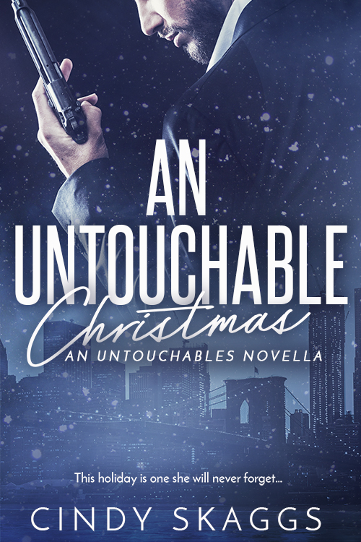
Sofia Capri survived life as a mob wife, but living with drop-dead gorgeous FBI agent Logan Stone has its own challenges. Step one? Host his family for Christmas dinner.

Rescuing Sofia from her former mob life and saving her kidnapped son was enough to earn Logan a place in her life, but a mysterious phone call before dinner threatens the security he'd give anything to provide.
When Sofia's son and Logan's nieces disappear from the festivities, the illusion of a normal Christmas shatters, hurling Sofia back into her nightmares.

Each book in the Untouchables series is a standalone, full-length story that can be enjoyed out of order.
Series Order:

Book #1 - Untouchable
Book #2 - An Untouchable Christmas, novella
Book #3 – Unforgettable (12/12/16)
Book #4 – due in April 2017

EXCERPT:

The white door contrasted the dark of her hair, framing her face so he couldn’t look away. Normally, she was buttoned up, but the new wispy layers of her hair were tousled from her nap. Added to the way her espresso-eyes narrowed with sleep, she screamed sex. Hot, needy, up against the wall, fast and dirty sex. One look and he was lost. Like the first time. Like every time.
Logan wrapped a hand around her neck and grabbed a handful of her silky hair. The back of her head dropped back to hit the door, and the way it angled her head, her eyelids drooped, hidden by mink lashes, creating an aura of mystery that drew him like a fine whiskey on the rocks. The bite of the ice on his tongue contrasting with the heat as it burned down his throat. Intoxicating. A path flamed down his body with the phantom whiskey, warming his gut and settling in his groin.
The tip of her tongue flicked to moisten her lips. No man could resist the invitation. The hands in her hair tightened, holding her into place as he ghosted his lips over hers. Their breath tangled, hers turning rough with each tease until her lower body arched off the door rattling in the frame. The kiss didn’t have a chance at short and sweet.

SHORT EXCERPT:
The look on Sofia’s face was an exact match to the one six months ago when she’d whispered the words they have my son. Logan shook his head, trying not to let his panic show. She went absolutely still. The noise died like someone had called for prayer. He couldn’t force the words out of his mouth. “Eli,” Sofia screamed up the stairs. Any kid within earshot would recognize the angry tone. Frantic energy vibrated off her as she moved to the bottom of the steps and hollered up. The silence was its own answer.

SHORT BIO:
Cindy Skaggs grew up on stories of mob bosses, horse thieves, cold-blooded killers, and the last honest man. Those mostly true stories gave her a lifelong love of storytelling and heroes. Her search for story took her around the world with the Air Force before returning to Colorado.
As a single mom, she’s turning her lifelong love of storytelling into the one thing she can’t live without: writing. She has an MA in Creative Writing, three jobs, two kids, and more pets than she can possibly handle. Find her on Facebook as Cindy Skaggs, Writer, @CLSkaggs on Twitter, or www.CSkaggs.com to sign up for her newsletter.

LINKS:
Website: http://www.cskaggs.com
Facebook: https://www.facebook.com/CSkaggs
Twitter: https://twitter.com/CLSkaggs
Goodreads: http://www.goodreads.com/CindySkaggs
Pinterest: https://www.pinterest.com/cindyskaggs/

BUY LINKS:
http://entangledpublishing.com/an-untouchable-christmas/
https://amzn.com/B01M5FGXQN

